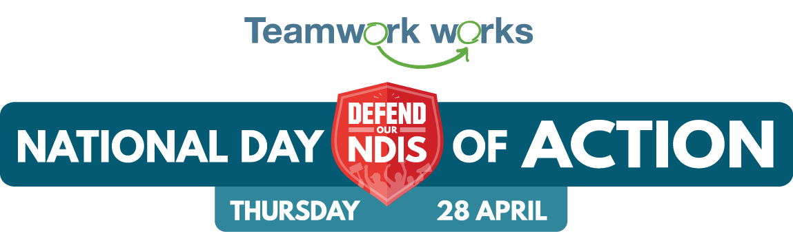

Template email to staff, clients, families

Hi {name | friend},

We’re getting involved in the National Day of Action to Defend our NDIS - and we want you to join us.

On Thursday 28th April people with disability, their teams, families and friends are all taking part in a National Day of Action.

There will be local events taking place right across the country, to make sure the NDIS is at the top of the agenda this federal election.

[Provider name] is hosting an event as part of the National day of Action, and we invite you to be part of it. The details are:

[event details]

Why is this important?

The NDIS was built to support Australians with disabilities for generations to come. It should be a great Australian social and economic reform we can all be proud of.

But right now the NDIS is at a crossroads.

People’s plans are being cut. Support is being cut.

This is not the NDIS people with disability deserve.

Federal Elections are a huge opportunity. Candidates listen very carefully to what people in their local communities want them to fight for if they are elected.

We need them to know that if they’re elected, we want them to defend our NDIS.

RSVP now to be part of our National Day of Action event.

We can't wait to see you there.

{Name}

