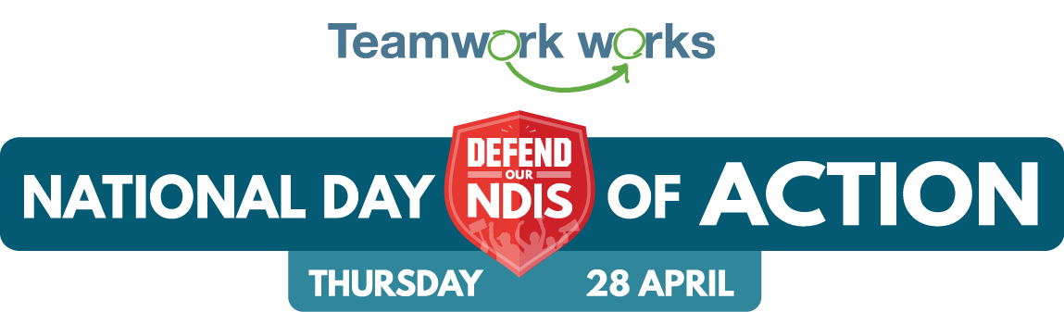

Template media release for events

[Location] based support provider, [insert organisation name] will join a National Day of Action on April 28 to defend the NDIS from cuts that are leaving local people with disability without critical supports.

[Organisation] CEO, [name], said local people with disability, their families, carers and disability workers had campaigned to establish the NDIS and were joining the National Day of Action to make sure it delivers on its potential.

“The National Day of Action will see people from all over Australia come together ahead of the Federal election to show all candidates and politicians how strongly local communities such as xx support the NDIS and how vital it is to so many people that it is fully funded and delivered in a way that puts people first,” [spokesperson’s name] said.

“At [organisation] we’re hearing too many stories from the local people we support of their funding being cut or changed without proper explanation.

“And we’re still seeing too many cases of people struggling to navigate a system that seems to focus on cost ahead of individualised supports.

“We were part of national celebrations when the NDIS was promised and we will all continue to make sure the scheme is delivered the way it was intended.”

The [event name] event will be held at [location, time, details]

[How people can be involved in your local event]

The National Day of Action on April 28 is part of the national Defend Our NDIS campaign, which has seen people from right across Australia come together in regional town hall rallies and events ahead of the upcoming election.

On 28 April people with disability, families, carers and support workers will be out in their local electorates, holding events, speaking to candidates, holding banners and making a noise on social media to spread the Defend Our NDIS message.

The campaign is being coordinated by grassroots disability campaign Every Australian Counts, together with the Teamworks campaign, led by National Disability Services, representing 1200 disability providers, including (insert name).

“This election we will be calling on all candidates to remember the purpose of the NDIS and commit to a scheme that treats people as human beings, not numbers,” Every Australian Counts campaign spokesperson, Elly Desmarchelier, said.

“It’s been so fantastic to see people from all over Australia come together, get involved in a forum or a local even and help defend our NDIS.”

NDS CEO Laurie Leigh said the NDIS was supporting local people with disability, as well as local economies in every part of Australia.

“Federal Elections are a huge opportunity. Candidates listen very carefully to what people in their local communities want them to fight for if they are elected,” Ms Leigh said.

“We need them to know that if they’re elected, we want them to defend our NDIS.”

Find out more about Defend Our NDIS and what’s planned at www.everyaustraliancounts.com.au

MEDIA CONTACT: [Contact name and phone number]

